Assignment 5

Ojaas Hampiholi

3/12/2020

## Question 1:

The transformation formula used for fitting the model is given below as follows:

### BMI.gam = gam(BMI ~ s(Age, Height), data = inputData)

## Question 2:

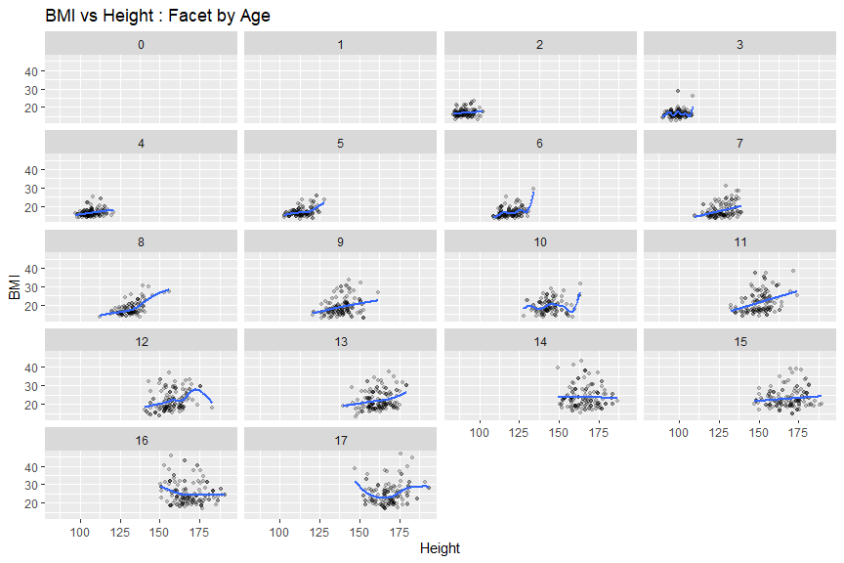

## Question 3:

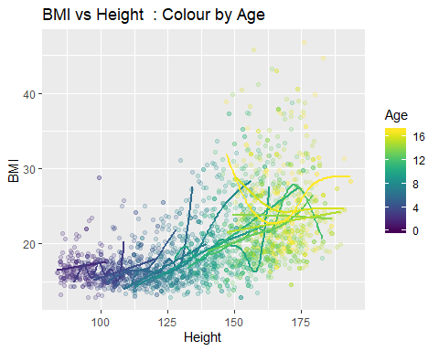

## Question 4:

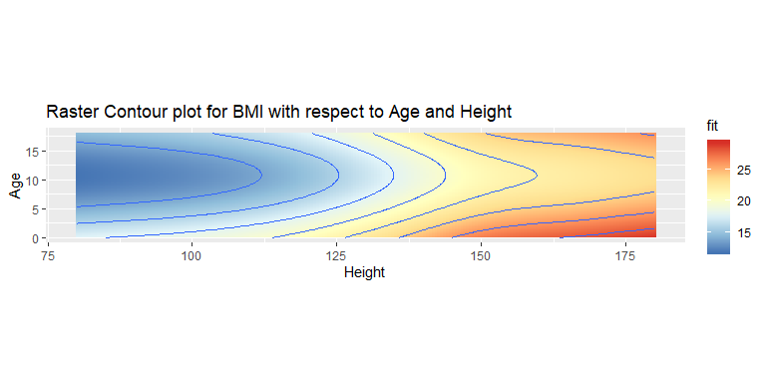

## 

## Question 5:

From the residual plots we can see that a GAM model fits suitably to the given data. When we look at the graph that shows the relation between Height and BMI faceted with respect to Age, we can see no clear trend or relation between Height and BMI which is carried the same across all Age groups. When we observe the plot for BMI vs Height which has Age represented by colour, we can once again see no relation between the graphs for BMI vs Height at different Age groups. When we look at the raster plot drawn for Age vs Height and BMI shows the color, we can see that the BMI is optimum for the height range of 120 to 140, while at the age range of 7 to 13. Keeping the above factors in mind we can say that there is no visible relationship between BMI and Height for the children age group (below 17 years of age). Hence, the main conclusion that can be derived from the data and the plots drawn above is that BMI is not a good measure of body mass for children.

## Appendix

##   
## Family: gaussian   
## Link function: identity   
##   
## Formula:  
## BMI ~ s(Age) + s(Height)  
##   
## Parametric coefficients:  
## Estimate Std. Error t value Pr(>|t|)   
## (Intercept) 19.93960 0.08886 224.4 <2e-16 ***  
## ---  
## Signif. codes: 0 '***' 0.001 '**' 0.01 '*' 0.05 '.' 0.1 ' ' 1  
##   
## Approximate significance of smooth terms:  
## edf Ref.df F p-value   
## s(Age) 3.233 4.139 10.97 6.17e-09 ***  
## s(Height) 5.422 6.608 16.29 < 2e-16 ***  
## ---  
## Signif. codes: 0 '***' 0.001 '**' 0.01 '*' 0.05 '.' 0.1 ' ' 1  
##   
## R-sq.(adj) = 0.366 Deviance explained = 36.8%  
## GCV = 17.605 Scale est. = 17.528 n = 2220

## `geom_smooth()` using method = 'gam' and formula 'y ~ s(x, bs = "cs")'

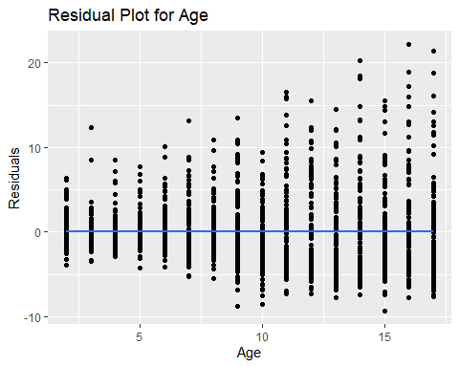

## `geom_smooth()` using method = 'gam' and formula 'y ~ s(x, bs = "cs")'

